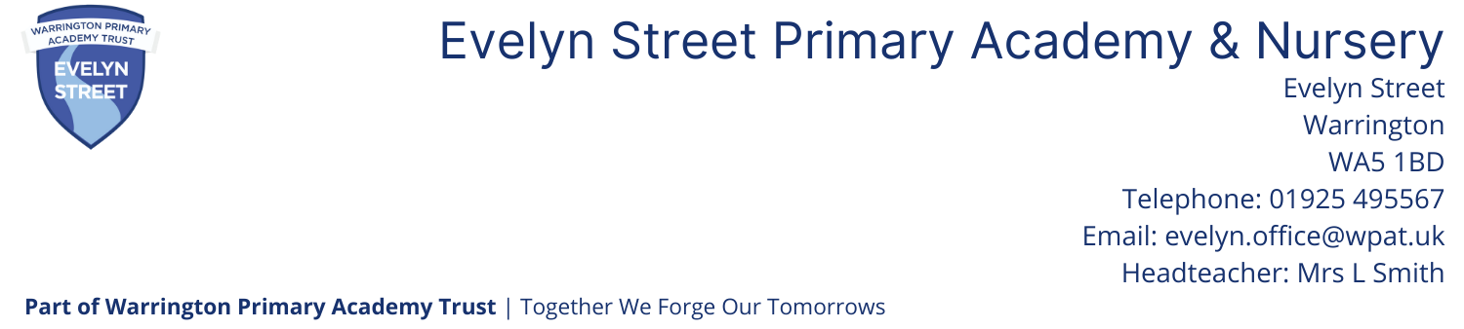

Teaching Assistant Part Time Fixed Term for 1 year (Extension possible)
Start Date: ASAP
Grade 4 Point 6 FTE £25,989 (This will be pro rata according to hours and weeks worked per year)
20 hours a week Term time plus 1 week

Warrington Primary Academy Trust and The Governing Body of Evelyn Street Primary School would like to appoint a motivated, inspiring and dedicated teaching assistant to join an excellent team of staff committed to delivering the highest standards of education.

Applicants will need to:
- Feel confident in their own Maths / English skills appropriate to demands of all key stages
- Have relevant, recent experience within the age range including Phonics experience
- Engage and support children in their learning through a variety of strategies, adjusting activities for the pupil they are working with to support learning styles and individual needs
- Feedback to teaching staff regarding progress and outcomes
- Have the ability to work constructively as part of a team
- Have a positive approach to managing behaviour
- Develop positive relationships with children, staff and parents to promote the progress and attainment of children
- Demonstrate a commitment to establishing high expectations and ensuring continuous progress and school improvement
- Engage in aspects of wider school life

We can offer the successful candidate:
- An Outstanding School (Ofsted 2024)
- A welcoming, caring and fully inclusive ethos
- Pupils with exemplary conduct, outstanding behaviour and positive attitudes to learning
- Outstanding role models for teaching
- An exciting and effective Creative Curriculum
- Supportive staff, parents and governors
- Excellent professional development opportunities

Prospective candidates are welcome to visit the school by appointment. All candidates are required to read our Safeguarding and Child Protection policy which is available to download on our website www.evelynstreetschool.co.uk

Our school is committed to safeguarding and promoting the welfare of children. The successful candidates will be required to apply for enhanced disclosure from the Disclosures & Barring Service. Further details can be found on homeoffice.gov.uk/agencies-public-bodies/dbs/

The application form and further details are available to download from our website: www.evelynstreetschool.co.uk

All applications should be marked for the attention of the Head teacher Mrs Smith

School Visits: Please contact the school office
Closing date: 12 noon Thursday 7th May 2026
Shortlisting: Friday 8th May 2026
Interviews: Week commencing Monday 11th May 2026

